DATASET ACTIVATE DataSet2.

DESCRIPTIVES VARIABLES=ToysOwned DaysToFail

/STATISTICS=MEAN STDDEV.

**Descriptives**

|  |  |  |
| --- | --- | --- |
| **Notes** | | |
| Output Created | | 08-MAR-2023 15:24:04 |
| Comments | |  |
| Input | Data | C:\Users\AD\Documents\Learn\SPSS\Lesson 7.sav |
| Active Dataset | DataSet2 |
| Filter | <none> |
| Weight | <none> |
| Split File | <none> |
| N of Rows in Working Data File | 50 |
| Missing Value Handling | Definition of Missing | User defined missing values are treated as missing. |
| Cases Used | All non-missing data are used. |
| Syntax | | DESCRIPTIVES VARIABLES=ToysOwned DaysToFail  /STATISTICS=MEAN STDDEV. |
| Resources | Processor Time | 00:00:00.00 |
| Elapsed Time | 00:00:00.01 |

|  |  |  |  |
| --- | --- | --- | --- |
| **Descriptive Statistics** | | | |
|  | N | Mean | Std. Deviation |
| Number of dogs owned | 50 | 6.08 | 3.746 |
| Number of days to chew | 50 | 8.98 | 4.192 |
| Valid N (listwise) | 50 |  |  |

FREQUENCIES VARIABLES=Favorite DogBreed DogSize ToyChosen

/BARCHART FREQ

/ORDER=ANALYSIS.

**Frequencies**

|  |  |  |
| --- | --- | --- |
| **Notes** | | |
| Output Created | | 08-MAR-2023 15:24:04 |
| Comments | |  |
| Input | Data | C:\Users\AD\Documents\Learn\SPSS\Lesson 7.sav |
| Active Dataset | DataSet2 |
| Filter | <none> |
| Weight | <none> |
| Split File | <none> |
| N of Rows in Working Data File | 50 |
| Missing Value Handling | Definition of Missing | User-defined missing values are treated as missing. |
| Cases Used | Statistics are based on all cases with valid data. |
| Syntax | | FREQUENCIES VARIABLES=Favorite DogBreed DogSize ToyChosen  /BARCHART FREQ  /ORDER=ANALYSIS. |
| Resources | Processor Time | 00:00:01.02 |
| Elapsed Time | 00:00:00.82 |

|  |  |  |  |  |  |
| --- | --- | --- | --- | --- | --- |
| **Statistics** | | | | | |
|  | | Favorite toys | Dog breed | The size of the dogs | Toy Chosen |
| N | Valid | 50 | 50 | 50 | 50 |
| Missing | 0 | 0 | 0 | 0 |

**Frequency Table**

|  |  |  |  |  |  |
| --- | --- | --- | --- | --- | --- |
| **Favorite toys** | | | | | |
|  | | Frequency | Percent | Valid Percent | Cumulative Percent |
| Valid | Chew Toy | 8 | 16.0 | 16.0 | 16.0 |
| Chirpy Bird | 11 | 22.0 | 22.0 | 38.0 |
| Rope Bone | 9 | 18.0 | 18.0 | 56.0 |
| Stuffed Monkey | 10 | 20.0 | 20.0 | 76.0 |
| Tennis Ball | 12 | 24.0 | 24.0 | 100.0 |
| Total | 50 | 100.0 | 100.0 |  |

|  |  |  |  |  |  |
| --- | --- | --- | --- | --- | --- |
| **Dog breed** | | | | | |
|  | | Frequency | Percent | Valid Percent | Cumulative Percent |
| Valid | Chihuahua | 16 | 32.0 | 32.0 | 32.0 |
| Fuzzy Dog | 18 | 36.0 | 36.0 | 68.0 |
| Retriever | 16 | 32.0 | 32.0 | 100.0 |
| Total | 50 | 100.0 | 100.0 |  |

|  |  |  |  |  |  |
| --- | --- | --- | --- | --- | --- |
| **The size of the dogs** | | | | | |
|  | | Frequency | Percent | Valid Percent | Cumulative Percent |
| Valid | Large | 14 | 28.0 | 28.0 | 28.0 |
| Medium | 20 | 40.0 | 40.0 | 68.0 |
| Small | 16 | 32.0 | 32.0 | 100.0 |
| Total | 50 | 100.0 | 100.0 |  |

|  |  |  |  |  |  |
| --- | --- | --- | --- | --- | --- |
| **Toy Chosen** | | | | | |
|  | | Frequency | Percent | Valid Percent | Cumulative Percent |
| Valid | Duck | 17 | 34.0 | 34.0 | 34.0 |
| Hedge Hog | 17 | 34.0 | 34.0 | 68.0 |
| Lamb Chop | 16 | 32.0 | 32.0 | 100.0 |
| Total | 50 | 100.0 | 100.0 |  |

**Bar Chart**

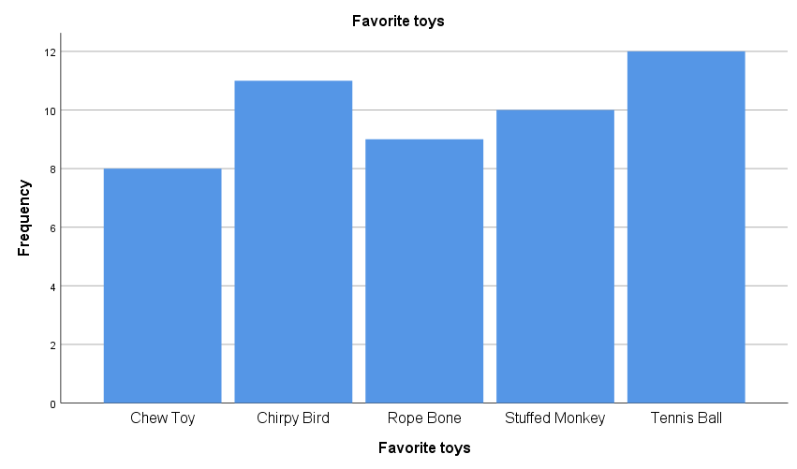

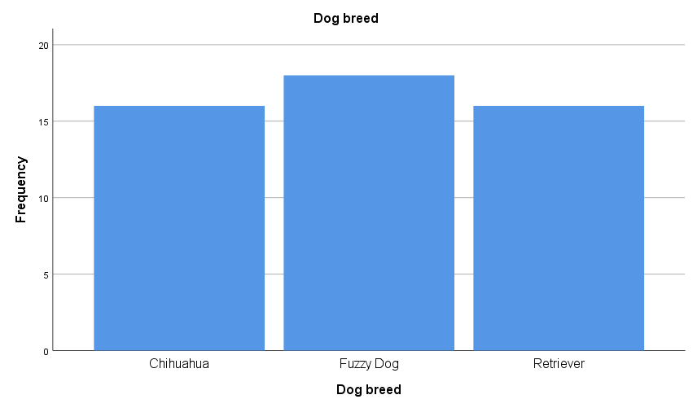

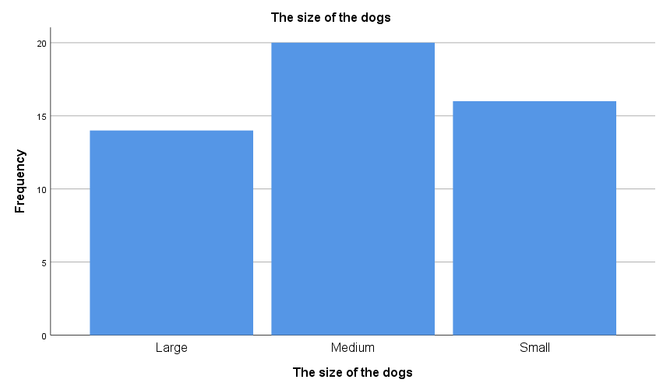

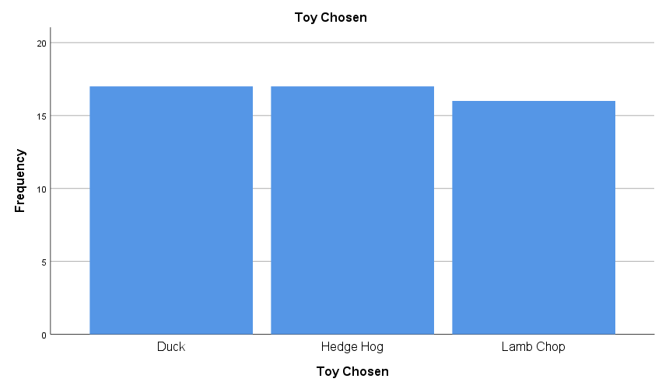

*RQ1 Does days to fail differ by the breed of dog?.

ONEWAY DaysToFail BY DogBreed

/STATISTICS DESCRIPTIVES HOMOGENEITY

/MISSING ANALYSIS

/POSTHOC=TUKEY ALPHA(0.05).

**Oneway**

|  |  |  |
| --- | --- | --- |
| **Notes** | | |
| Output Created | | 08-MAR-2023 15:24:05 |
| Comments | |  |
| Input | Data | C:\Users\AD\Documents\Learn\SPSS\Lesson 7.sav |
| Active Dataset | DataSet2 |
| Filter | <none> |
| Weight | <none> |
| Split File | <none> |
| N of Rows in Working Data File | 50 |
| Missing Value Handling | Definition of Missing | User-defined missing values are treated as missing. |
| Cases Used | Statistics for each analysis are based on cases with no missing data for any variable in the analysis. |
| Syntax | | ONEWAY DaysToFail BY DogBreed  /STATISTICS DESCRIPTIVES HOMOGENEITY  /MISSING ANALYSIS  /POSTHOC=TUKEY ALPHA(0.05). |
| Resources | Processor Time | 00:00:00.02 |
| Elapsed Time | 00:00:00.02 |

|  |  |  |  |  |  |  |  |  |
| --- | --- | --- | --- | --- | --- | --- | --- | --- |
| **Descriptives** | | | | | | | | |
| Number of days to chew | | | | | | | | |
|  | N | Mean | Std. Deviation | Std. Error | 95% Confidence Interval for Mean | | Minimum | Maximum |
| Lower Bound | Upper Bound |
| Chihuahua | 16 | 5.06 | 2.016 | .504 | 3.99 | 6.14 | 1 | 8 |
| Fuzzy Dog | 18 | 8.78 | 2.510 | .592 | 7.53 | 10.03 | 2 | 12 |
| Retriever | 16 | 13.13 | 3.384 | .846 | 11.32 | 14.93 | 9 | 20 |
| Total | 50 | 8.98 | 4.192 | .593 | 7.79 | 10.17 | 1 | 20 |

|  |  |  |  |  |  |
| --- | --- | --- | --- | --- | --- |
| **Test of Homogeneity of Variances** | | | | | |
|  | | Levene Statistic | df1 | df2 | Sig. |
| Number of days to chew | Based on Mean | 1.910 | 2 | 47 | .159 |
| Based on Median | 1.669 | 2 | 47 | .199 |
| Based on Median and with adjusted df | 1.669 | 2 | 39.581 | .201 |
| Based on trimmed mean | 1.724 | 2 | 47 | .189 |

|  |  |  |  |  |  |
| --- | --- | --- | --- | --- | --- |
| **ANOVA** | | | | | |
| Number of days to chew | | | | | |
|  | Sum of Squares | df | Mean Square | F | Sig. |
| Between Groups | 521.181 | 2 | 260.591 | 36.044 | .000 |
| Within Groups | 339.799 | 47 | 7.230 |  |  |
| Total | 860.980 | 49 |  |  |  |

**Post Hoc Tests**

|  |  |  |  |  |  |  |
| --- | --- | --- | --- | --- | --- | --- |
| **Multiple Comparisons** | | | | | | |
| Dependent Variable: Number of days to chew | | | | | | |
| Tukey HSD | | | | | | |
| (I) Dog breed | (J) Dog breed | Mean Difference (I-J) | Std. Error | Sig. | 95% Confidence Interval | |
| Lower Bound | Upper Bound |
| Chihuahua | Fuzzy Dog | -3.715* | .924 | .001 | -5.95 | -1.48 |
| Retriever | -8.062* | .951 | .000 | -10.36 | -5.76 |
| Fuzzy Dog | Chihuahua | 3.715* | .924 | .001 | 1.48 | 5.95 |
| Retriever | -4.347* | .924 | .000 | -6.58 | -2.11 |
| Retriever | Chihuahua | 8.063* | .951 | .000 | 5.76 | 10.36 |
| Fuzzy Dog | 4.347* | .924 | .000 | 2.11 | 6.58 |

|  |
| --- |
| *. The mean difference is significant at the 0.05 level. |

**Homogeneous Subsets**

|  |  |  |  |  |
| --- | --- | --- | --- | --- |
| **Number of days to chew** | | | | |
| Tukey HSDa,b | | | | |
| Dog breed | N | Subset for alpha = 0.05 | | |
| 1 | 2 | 3 |
| Chihuahua | 16 | 5.06 |  |  |
| Fuzzy Dog | 18 |  | 8.78 |  |
| Retriever | 16 |  |  | 13.13 |
| Sig. |  | 1.000 | 1.000 | 1.000 |

|  |
| --- |
| Means for groups in homogeneous subsets are displayed. |
| a. Uses Harmonic Mean Sample Size = 16.615. |
| b. The group sizes are unequal. The harmonic mean of the group sizes is used. Type I error levels are not guaranteed. |

*RQ2 -> Is favorite toys related to sized of dogs?.

CROSSTABS

/TABLES=Favorite BY DogSize

/FORMAT=AVALUE TABLES

/STATISTICS=CHISQ PHI

/CELLS=COUNT ROW

/COUNT ROUND CELL

/BARCHART.

**Crosstabs**

|  |  |  |
| --- | --- | --- |
| **Notes** | | |
| Output Created | | 08-MAR-2023 15:24:05 |
| Comments | |  |
| Input | Data | C:\Users\AD\Documents\Learn\SPSS\Lesson 7.sav |
| Active Dataset | DataSet2 |
| Filter | <none> |
| Weight | <none> |
| Split File | <none> |
| N of Rows in Working Data File | 50 |
| Missing Value Handling | Definition of Missing | User-defined missing values are treated as missing. |
| Cases Used | Statistics for each table are based on all the cases with valid data in the specified range(s) for all variables in each table. |
| Syntax | | CROSSTABS  /TABLES=Favorite BY DogSize  /FORMAT=AVALUE TABLES  /STATISTICS=CHISQ PHI  /CELLS=COUNT ROW  /COUNT ROUND CELL  /BARCHART. |
| Resources | Processor Time | 00:00:00.37 |
| Elapsed Time | 00:00:00.21 |
| Dimensions Requested | 2 |
| Cells Available | 524245 |

|  |  |  |  |  |  |  |
| --- | --- | --- | --- | --- | --- | --- |
| **Case Processing Summary** | | | | | | |
|  | Cases | | | | | |
| Valid | | Missing | | Total | |
| N | Percent | N | Percent | N | Percent |
| Favorite toys * The size of the dogs | 50 | 100.0% | 0 | 0.0% | 50 | 100.0% |

|  |  |  |  |  |  |  |
| --- | --- | --- | --- | --- | --- | --- |
|  | | | | | | |
|  | | | The size of the dogs | | | Total |
| Large | Medium | Small |
| Favorite toys | Chew Toy | Count | 1 | 4 | 3 | 8 |
| % within Favorite toys | 12.5% | 50.0% | 37.5% | 100.0% |
| Chirpy Bird | Count | 4 | 4 | 3 | 11 |
| % within Favorite toys | 36.4% | 36.4% | 27.3% | 100.0% |
| Rope Bone | Count | 1 | 2 | 6 | 9 |
| % within Favorite toys | 11.1% | 22.2% | 66.7% | 100.0% |
| Stuffed Monkey | Count | 3 | 5 | 2 | 10 |
| % within Favorite toys | 30.0% | 50.0% | 20.0% | 100.0% |
| Tennis Ball | Count | 5 | 5 | 2 | 12 |
| % within Favorite toys | 41.7% | 41.7% | 16.7% | 100.0% |
| Total | | Count | 14 | 20 | 16 | 50 |
| % within Favorite toys | 28.0% | 40.0% | 32.0% | 100.0% |

|  |  |  |  |
| --- | --- | --- | --- |
| **Chi-Square Tests** | | | |
|  | Value | df | Asymptotic Significance (2-sided) |
| Pearson Chi-Square | 8.763a | 8 | .363 |
| Likelihood Ratio | 8.640 | 8 | .374 |
| Linear-by-Linear Association | 1.730 | 1 | .188 |
| N of Valid Cases | 50 |  |  |

|  |
| --- |
| a. 15 cells (100.0%) have expected count less than 5. The minimum expected count is 2.24. |

|  |  |  |  |
| --- | --- | --- | --- |
| **Symmetric Measures** | | | |
|  | | Value | Approximate Significance |
| Nominal by Nominal | Phi | .419 | .363 |
| Cramer's V | .296 | .363 |
| N of Valid Cases | | 50 |  |

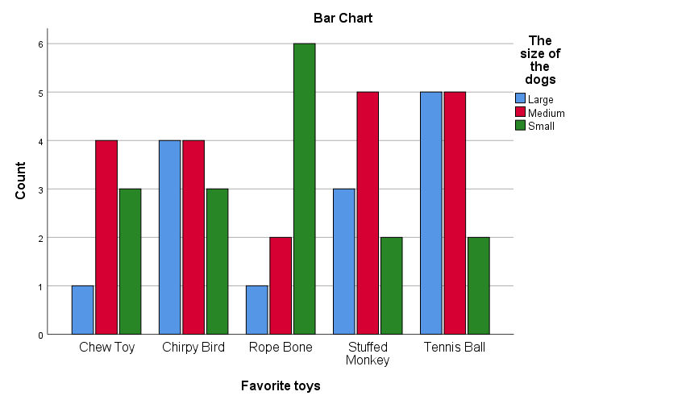

*RQ3 -> Is number of toys owned related to days of failure?.

CORRELATIONS

/VARIABLES=ToysOwned DaysToFail

/PRINT=TWOTAIL NOSIG

/MISSING=PAIRWISE.

**Correlations**

|  |  |  |
| --- | --- | --- |
| **Notes** | | |
| Output Created | | 08-MAR-2023 15:24:05 |
| Comments | |  |
| Input | Data | C:\Users\AD\Documents\Learn\SPSS\Lesson 7.sav |
| Active Dataset | DataSet2 |
| Filter | <none> |
| Weight | <none> |
| Split File | <none> |
| N of Rows in Working Data File | 50 |
| Missing Value Handling | Definition of Missing | User-defined missing values are treated as missing. |
| Cases Used | Statistics for each pair of variables are based on all the cases with valid data for that pair. |
| Syntax | | CORRELATIONS  /VARIABLES=ToysOwned DaysToFail  /PRINT=TWOTAIL NOSIG  /MISSING=PAIRWISE. |
| Resources | Processor Time | 00:00:00.00 |
| Elapsed Time | 00:00:00.01 |

|  |  |  |  |
| --- | --- | --- | --- |
| **Correlations** | | | |
|  | | Number of dogs owned | Number of days to chew |
| Number of dogs owned | Pearson Correlation | 1 | .239 |
| Sig. (2-tailed) |  | .094 |
| N | 50 | 50 |
| Number of days to chew | Pearson Correlation | .239 | 1 |
| Sig. (2-tailed) | .094 |  |
| N | 50 | 50 |